BEGINNERS 2.0-2.5 Thursday -JUNE 8th FROM 6:00-7:15
PICKLEBALL LESSONS AT GREGG PARK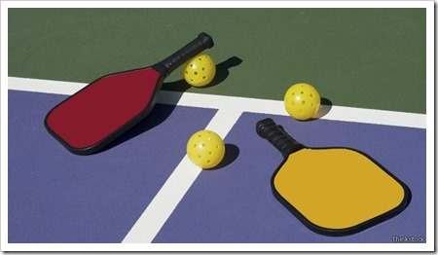
$25 PER PERSON– Must have your own paddle– Space is Limited Email registration form to vincennespickleball@gmail.com

This is a beginner class. Players in this class will …..
___Learn more about the strategies of Pickleball
___Feel confident you are in the right space on the court
___Practice a volley, a serve, & a dink
___Meet other players on their level

Take this class if you…………..
___Have some tennis, or racquetball background
___Have played some Pickleball & know how to keep score
___Can sustain a short rally with players of equal ability
___Are just now learning to be competitive at Pickleball

******No Shows will NOT be Refunded Registration Fee******
Pickleball Lessons at Gregg Park Registration form
Beginner Session Thursday June 8th 6:00-7:15

Name_____________________ Cell___________________

Age______ (if under 18 must have consent of guardian)

_______I agree to waive and release all liability while participating in this activity. I agree to hold harmless all instructors, volunteers, and the Vincennes Parks while participating in this activity.

____________________________ __________
Signature Date

$25 Payment Received ____________ (date)
____ Venmo @Vanessa-Purdom 5537
____Cash
____Check – Payable to Vincennes Parks and Rec

Questions – vincennespickleball@gmail.com or Text 580-799-5537

