City of Vincennes
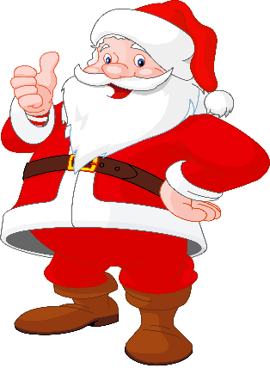
Christmas in the Park Drive Through
This Photo by Unknown Author is licensed under CC BY-NC
Friday, December 4, 2020
& Saturday, December 5, 2020
6:00 p.m. – 9:00 p.m.

RULES & INSTRUCTIONS

- This year’s theme is: “Christmas in the Park”
- All entries must be decorated and lit using your own power source.
- The parade committee reserves the right to reject any entry forms.
- Masks will be required for participants.
- The City of Vincennes will host Santa for the event. No other Santa’s will be allowed.
-------------------------------------------------------------------------------------------------------

ENTRIES MUST BE RECEIVED BY Monday, November 30, 2020. NO LATE ENTRIES!

*** must be filled out completely ***

Organization ____________________________________________________________________

Address ________________________________________________________________________

Contact Person _______________________________ Phone Number_______________________

Contact Person’s Email Address_____________________________________________________

WILL YOU PARTICIPATE:
Friday Evening: ______ Saturday Evening: ______ Both Evenings: ______

CATEGORY (choose one)
___Business/Corporation ___ Band ___Non-Profit
___Service Organization _____ Dance/Gymnastics
___Specialty Unit; describe ___________________________

Entry Dimensions (Include vehicles & participants): ______L ______W ______H

(spaces will be 10’ apart to allow for social distancing)

Locations will be sent via e-mail once finalized.
*Map will also be posted on www.vincennes.org & Vincennes Mayor’s Office Facebook page

Entries may be returned by:
Email: chacker@vincennes.in.gov
Mail: 201 Vigo Street, Vincennes, IN 47591

